Campus Information for Students

2022-2023

TABLE OF CONTENTS

1. | General Information……….……………………………………..…. | 2
2. | Campus Security, Safety, Emergency Procedures…………. | 2
3. | Campus Access…………………………………………………………. | 4
4. | Student Parking………………………………………………………… | 4
5. | Library Services………………………………………………………… | 5
6. | Student Health Services…………………………………………….. | 5
7. | Needle Sticks/Sharps Injuries/Body Fluid Exposures…… | 7
8. | Student Wellness/Mental Health Services…………………… | 10
9. | Student Success Center……………………………………………… | 11
10. | Razorback Tickets for NW Campus Students…………….… | 12
11. | Student Fitness………………………………………………………… | 13
12. | Campus Logo Merchandise……………………………………….. | 16
13. | Associated Student Government (ASG)………………………. | 16
14. | Mobile Food Pantry Services……………………………………… | 17
 | Appendix A: Emergency Preparedness……………………….. | 18

Students are expected to follow all policies established by the University of Arkansas System Board of Trustees, the University of Arkansas for Medical Sciences, and their respective college of study. UAMS Northwest Campus-specific information is summarized below.
Procedures stated in this handbook require continuing evaluation, review and approval by appropriate University of Arkansas for Medical Science (UAMS) officials. All statements contained herein should reflect policies in existence at the time this handbook was completed, and UAMS reserves the right to change policies at any time and without prior notice. The campus, school, university and its officials reserve the right to make modifications at any time and without prior notice. All campus students are responsible for the information contained in this handbook, as well as the content of any and all other applicable handbooks and catalogs.
For the intents and purposes of this document, “the University” refers to the University of Arkansas for Medical Sciences and “the Campus” refers to the University of Arkansas for Medical Sciences Northwest campus in Fayetteville, Arkansas.

- General Information

All students are required to wear their UAMS student ID badge at all times on campus property or at any time representing UAMS at an off-campus rotation or event.

In addition, all students are required to check their UAMS email at least once a day for campus updates and non-emergency information.

- Campus Security

The University of Arkansas Police Department is the security team for the UAMS Northwest Campus.

If anyone is ever in a situation on campus where they are concerned for their personal safety or are experiencing a medical emergency either before, during, or after hours, they should contact them directly for assistance.

Non-emergency number: (479) 575-2222

For emergencies: 9-1-1 from your mobile phone
or
8+ 9-1-1 from a UAMS campus phone/landline

In either situation, they should tell dispatch that they are on the UAMS Northwest Campus and give them their location i.e. Library, Nursing Classroom, etc. so the police can assist as quickly as possible.
EMERGENCY PREPAREDNESS Information & Codes: See Exhibit A, page 18

- Campus Access

The UAMS student ID badge will be activated to allow access to designated locations on the Northwest Campus. This badge provides access during and after-hours to locations on campus including:

- Building entrance from North Street
- Library double doors
- All student lounge areas (Medicine, Physical Therapy, Pharmacy)
- All academic classrooms and conference rooms
- UAMS NW Fitness Center

Please check the scheduler located outside each classroom for availability. All areas are to be kept clean and furniture arrangement/set up returned to how it was found before leaving.

- Student Parking

A parking sticker and a hangtag is provided to each student. Either the sticker or the hangtag must be present on any vehicle on campus. The sticker should be attached on the inside right rear window.

Between 8:00 am – 5:00 pm, students have two options to park (see map below):

Option #1: Corner of North & Park Street on the same side of the road as the Northwest campus. This lot is to the west of the “IT” building, toward Woolsey and the WRMC Cancer Home.
Option #2: Across North Street from Academic/Library entrance. NOTE: You MUST press the button for the flashing lights and make eye contact before crossing the street.

Between 5:00 pm and 8:00 am, you may park in any lot on campus, i.e. front of library, upper parking deck, etc. Students do not have entry access from lower parking/employee deck.

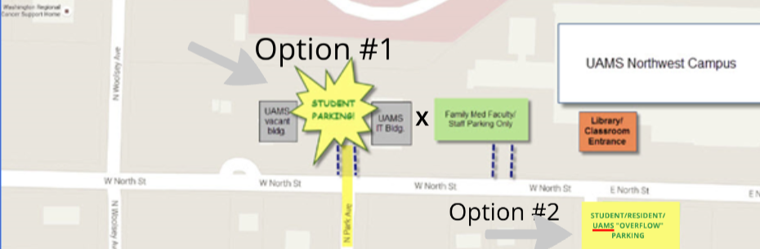

- Library Services

The information resources and services of the UAMS Northwest Campus Library are designed to meet the education, research, patient care, and service missions of UAMS.

Students at the UAMS Northwest Campus will have access to all electronic resources provided by the UAMS Main Campus in Little Rock via http://www.library.uams.edu. No Library account is required; students will use their UAMS login to access all electronic resources. For Library information specific to UAMS Northwest campus, please visit https://libguides.uams.edu/NWCLibrary.

Students also have access to the Library’s InterLibrary Loan (ILLiad) service for materials not owned by the Library. ILL services are free to all UAMS individuals. ILL requests for journal articles are usually provided in PDF format. The average turnaround time for electronic requests is 1-10 business days. The average turnaround time for a book could take longer, since the physical book will be shipped to the Library.

The Library location at 1125 N College is staffed Monday through Friday 8:00 a.m. to 4:00 p.m. excluding University holidays and if UAMS calls an Inclement Weather day. The Library is located at the Academic Entrance to campus directly off of North Street. The study areas (double doors on left immediately after building entry) are available 24/7 with the student UAMS ID badge. 24/7 access areas include study space, computer use, printing, and Wi-Fi access.

The librarian for the UAMS Northwest Campus is Kay Strahan, MSLIS. Her email is kstrahan@uams.edu and her phone number is 479-521-7615. She is here to assist students with their education and research needs, including but not limited to:
- Effectively searching in Library databases
- RefWorks citation management software
- Understanding and Avoiding Plagiarism

6. Student Health Services

The Student Health Clinic at UAMS provides access to treatment of acute illnesses, wellness visits, health promotion services and continual health education for all current UAMS students. Although the Student Health Clinic (SHC) is located on the UAMS campus in Little Rock, Northwest Campus (NW) students have access virtually to healthcare through the SHC. The procedure below outlines the process for a UAMS NW student is to access healthcare services that are covered by the Student Health Fee.
- To begin the process for treatment, and in order to access the benefits of the Student Health Fee, a UAMS NW student should call the UAMS Student Health Clinic (SHC) @ 501-686-6381 to schedule a Telehealth Appointment. The SHC is open Monday - Friday from 8am – 4:30pm. Students should specify they are a NW Campus student when making an appointment.

- Telehealth Appointment:
  - The SHC Provider(s) will provide assessment via telehealth and triage as needed.
    - SHC Provider can order any necessary tests (e.g., Strep, Flu, x-ray, etc.) to be provided by the Internal Medicine or Family Medicine Primary Care clinics, both located on the UAMS NW Campus in Fayetteville.
    - SHC Provider can prescribe medication as needed (e.g., antibiotics, etc.)
    - The cost of point-of-care tests are covered by the SHC.
      - Please note, if the student initially seeks medical care from a provider outside the SHC and point-of-care tests are ordered and expenses incurred, the SHC will be unable to reverse the charges and the student/student’s insurance will be financially responsible for the cost of tests.
    - If during the course of the appointment the SHC provider determines that the student needs a face-to-face appointment (e.g., Physician Office, Urgent Care, Emergency Room) the SHC provider will make the referral. In this case, the student/student’s insurance will be financially responsible for the visit. The SHC provider will ask student if they have an established provider, and if so, the referral will go to the established provider. If not, a local provider will be found.

- After Hours Care: If a NW student is in need or urgent or emergency care, call 911 or go to the nearest emergency department. If a NW campus student is sick or has a minor injury and needs to talk to someone right away, they can access https://uamshealth.com/healthnow/ for a video visit with a UAMS Health provider 24 hours a day, 7 days a week. If a student seeks care from Urgent Care or a local hospital, the student/student’s insurance is financially responsible and not covered by the Student Health Fee.
- The Student Health Clinic provides an anonymous virtual option for students to ask health questions to an APN. The “Ask the APN” resource can be found on the website: https://uamshealth.com/university-healthcare/student-health-clinic/ask-the-apn/.
- For further information for services covered by Student and Employee Health (SEHS), please visit https://uamshealth.com/university-healthcare/student-and-employee-health/.

7. Needle Stick/Sharps Injuries and Body Fluid Exposures
In summary for Northwest Campus students:
- Cease activity immediately & report incident to supervisor or preceptor in room
- Seek treatment at site according to their exposure policy & reporting requirements.
- Call Northwest Campus respective college to report incident on way to treatment
- If treatment is refused at offsite facility, seek treatment at nearest emergency room or physician’s office.
- Regardless of where treatment is received, the student must complete the UAMS Injury & Incident report within 24 hours of incident: http://www.uams.edu/campusop/depts/ohs/forms/Accident.aspx
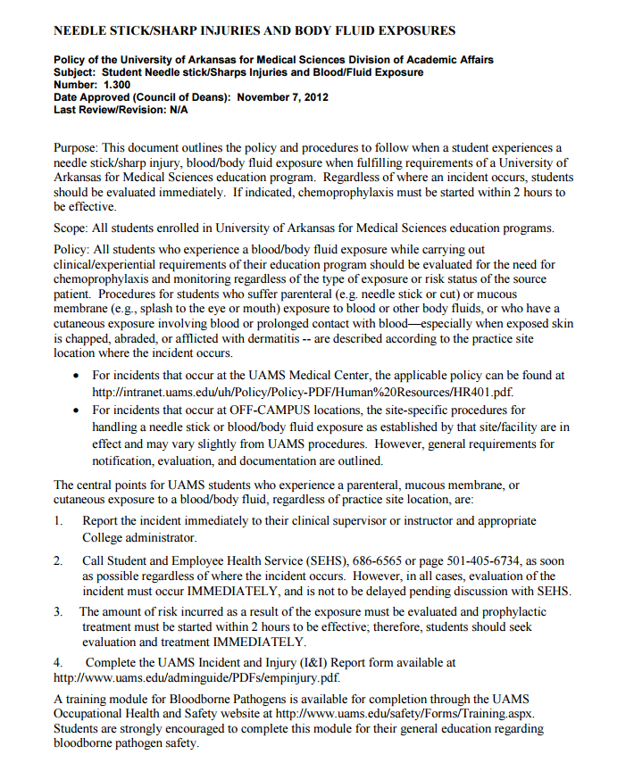
UAMS Policy:
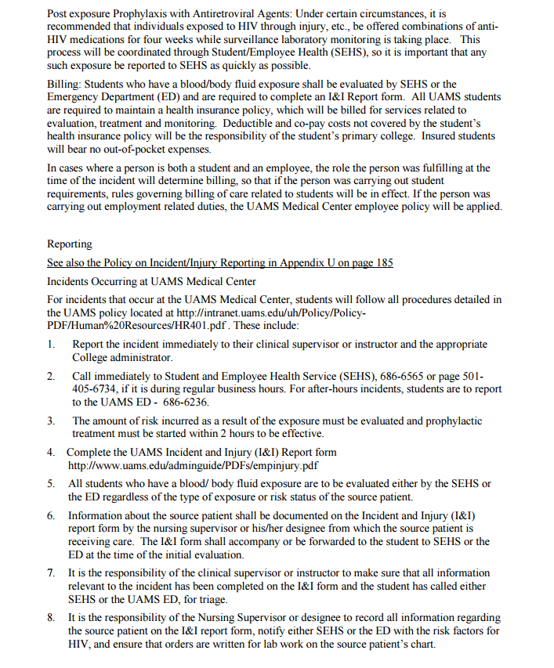
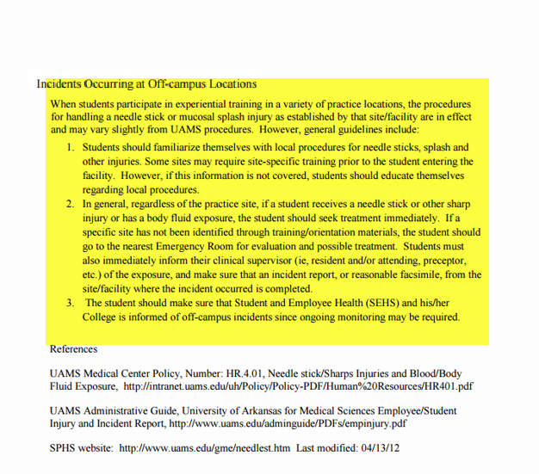8. Student Wellness/Mental Health Services

As a UAMS student, if you are experiencing any kind of emotional/ behavioral/ mental health difficulties, we will provide free, confidential mental health services.

UAMS Northwest Wellness Program can help with many issues, including but not limited to: Depression, anxiety, grief, relationship conflicts, academic difficulties, test anxiety, and numerous other issues interfering with your maximal functioning.

Who will provide these services on the Northwest Campus?

Our clinic provides care from a psychiatrist who can oversee medication management and psychiatric evaluation. We also have a licensed counselor who can provide couples therapy, individual therapy, family therapy, psychoeducation, and group therapy.

Where is this clinic located?

UAMS Northwest Wellness Program is located on the UAMS Northwest Campus in the annex building facing Woolsey and North Street, right next to student parking lot.

How Do I Schedule an Appointment to Get Help?

- To schedule an appointment, please call 479-713-8313 between 8:00 AM – 5:00 PM, Monday through Friday, or email at FAYam@uams.edu.

- If you are experiencing a life-threatening condition or emergency, please call 9-1-1 or go to the nearest emergency room.

- If you are having suicidal thoughts, you can call National Suicide Prevention Lifeline at 1-800-273-TALK (8255) to talk to trained counselors. This service is open 24/7 and is free. You can also use the 24/7 free National Crisis Text Line. Simply text TALK to 741741 to communicate with a trained counselor via text.

How Much Will It Cost Me?

This is a free service to UAMS students. You are only responsible for the cost of the medications if you are prescribed any, or for any special psychological testing if indicated.

How Soon Can I Expect to Be Seen?

Depending on the urgency, the UAMS NW Wellness Program will ensure that you are seen by a mental health professional within 0-5 days.

Is this Confidential?

This service is absolutely confidential (exceptions: suicidality/ homicidality/child abuse, or you give us permission). Medical records are maintained on paper and are not part of an electronic medical records system connected to any hospital or clinic.

9. Student Success Center

The Student Success Center provides services to students of all colleges & programs. Lian Taylor is the Student Learning Specialist on the Northwest campus. Learning services include academic coaching (time management, study skills, test preparation, test-taking, test anxiety) and peer tutoring. Her office is on the 1st/Academic floor across from the West elevators. Contact Lian for an appointment at 479-332-0208 or LTaylor3@UAMS.edu.

10. Razorback Tickets for Northwest Campus Students

- Razorback Access Pass: $100
  - Admission to home football and men’s basketball games
  - Official Trough t-shirt
  - Little Rock game available for first 2,000 students who pick up voucher
- Razorback Access Pass + Collegiate Membership to Razorback Foundation: $115
  - Everything above, PLUS
  - Exclusive event with head football coach
  - Private practice with head basketball coach
  - Invitations to exclusive events incl. Red Tie, Membership Appreciation, and Signing Day
  - Razorback Foundation rewards packet
  - Early admission to select events
  - Priority ticket access for Southwest Classic football game in Dallas and bowl game seating

Procedure for UAMS Northwest Students:
  - Visit this link to purchase tickets: https://arkansasrazorbacks.com/student-tickets/
  - If purchased last year, students can sign in using their email or student ID # and the password they created.
  - If not purchased previously, they click on Register Your Student Account and follow those steps to setup account/password.
  - For all questions, please contact the University of Arkansas ticket office at 800-982-HOGS/479-575-5151, or email them at RazTk@uark.edu

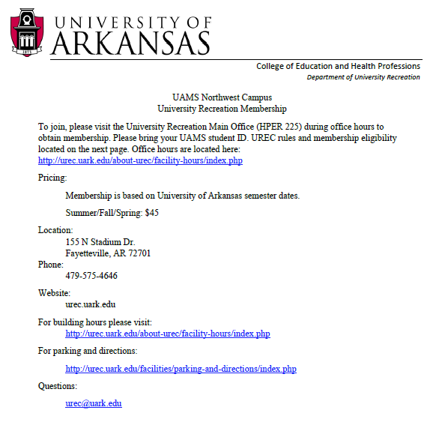
11. Student Fitness- University of Arkansas HPER and UAMS Northwest Fitness Center

Membership Eligibility
All students of the NWA branch of UAMS and AHEC Students within NWAUAMS are eligible to
purchase a UREC Membership. NWAUAMS and AHEC Students must present their NWAUAMS ID
upon purchasing the UREC membership. Due to a student’s status being determined upon continued enrollment each semester, all students may only purchase a semester membership. Memberships can be purchased at UREC facilities during Membership Office hours of operation.
Semester rate: $45.00

Family Member Eligibility
NWAUAMS Student Family memberships may be purchased for spouse/partner and dependents (under the age of 26 and residing within the household). Family members age 16 and older can be issued a UREC ID Card and can then access the building alone. In order to obtain a NWAUAMS Student Spouse/Partner membership, the pair must show documentation as detailed on the back of this sheet. A
family membership cannot be purchased without an individual NWAUAMS Student membership. Semester rate: $25.00

Mid-Semester Memberships
Upon the halfway point of each semester, a NWAUAMS Student Member is eligible to purchase a mid- semester membership for the remainder of the semester. Purchase price is 50% of the full membership cost.

Facility Access

NWAUAMS Student Members must obtain a UREC ID membership card from the Membership Office
within the HPER. NWAUAMS Student Members must present a UA or UREC ID upon entering UREC
facilities.
A UREC membership provides access to: HPER Building
UREC Fitness Center (ARKU location)
Group Fitness Program - The registration allows unlimited attendance to all Group Fitness, Group Cycle, Mind/Body, and Water Fitness classes for the semester. Additional charge of $40.00 for each NWAUAMS Student Family Member, or $3.00 per class, per persons
Guest Pass at $10.00, with a limit of three (3) guests per visit

Member Services
NWAUAMS Student Members are eligible to rent lockers. Locker rental must correspond with the date of membership expiration. Locker upgrades can be purchased at any time, subject to availability.
Questions
For NWAUAMS Student membership info, contact the UREC membership office at 479-575-6381. For
NWAUAMS access questions, please direct those to Leslie Hicks with NWAUAMS.

UREC Building Usage Policies
All memberships include periods that the HPER Building or related facilities are closed for holidays, athletic events, UREC events,
maintenance, renovation, and other times requiring closing of the building and/or specific facilities. For detailed hours of operation visit http://urec.uark.edu/7521.htm. The following rules and regulations are provided as a summary and are not all-inclusive. For a
complete copy of UREC facility rules and regulations, please visit urec.uark.edu
UREC Memberships holders are expected to:

Display appropriate behavior and follow all university codes of conduct
Utilize appropriate language during all situations
Follow all UREC facilities policy and procedure
Users are expected to be aware of University of Arkansas behavior policies. These policies can be found in the Faculty Handbook, Staff Handbook, and various Student Handbooks and publications
The UREC Staff have the authority to terminate an activity and remove individuals and/or teams from UREC facilities for violation of building, program, and university policies

All users must follow current university and UREC ID card policies. Only court shoes are allowed in activity areas with wooden floors. The building must be vacated by the scheduled closing time.

Spouses are those persons who are recognized by the State of Arkansas as being legally married. A valid marriage certificate or other documentation accepted by the State of Arkansas for proof of marriage may be required.
Partners are those persons who meet the following conditions:

Sole domestic partner and intend to remain so indefinitely, jointly responsible for each other.
Jointly responsible for each other’s common welfare, share financial obligations, and share primary residence. Joint responsibility may be demonstrated by the existence of two or more of the following: a joint real estate mortgage, lease or deed; current beneficiary designation naming the domestic partner as a beneficiary of life insurance, retirement plan, or a will; joint ownership of a motor vehicle; joint checking and/or savings account; joint credit account.

Not married to anyone and are at least eighteen (18) years of age and mentally competent to consent to contact. Not related by blood to a degree of closeness that would prohibit marriage in the state of Arkansas.
A completed domestic partnership affidavit may be required to purchase a membership.

Children, four (4) years of age and older may not enter the locker room of the opposite sex. UREC employees cannot accompany children into the locker rooms to assist with the changing of clothes, restroom breaks, etc. Parents must make the appropriate accommodations with their eligible family members or family acquaintances to assist the younger children.
Guests: 1) Members are responsible for their guests and must remain with them while using UREC facilities; 2) the guest access provides access to the UREC facilities for the single visit. Locker and towel service is available on a daily basis for $1.00 for each
service item; 3) Members may purchase guest passes in advance upon request; 4) a dependent under the age of 18 cannot sponsor a guest.
Personal belongings are the responsibility of the owner. Do not leave personal belongings unattended in the HPER Building.
Personal belongings are not permitted in the activity areas. Members are encouraged to use the locker system to store personal belongings. Lockers are available for a nominal fee and, if kept locked, provide security for personal possessions. Any personal locks
found on a locker will be cut off and the belongings will be stowed for no longer than 10 business days. A storage retrieval fee will
be charged before the items will be returned to the members. UREC is not responsible for lost or stolen items.
Refunds may be requested for all or portions of a purchase. All refunds will require a $25.00 administrative charge and the approval of the UREC Director. Refunds requested by 4:00 pm of the third (3rd) business day following the transaction will be considered for
the full amount minus the $25.00 administrative fee. Refunds or cancellations due to extenuating circumstances may be issued after
the third (3rd) business day for a prorated amount. All refunds will be reviewed and approved by the Director.
The following extenuating circumstances will be considered for refunds or cancellations after the 3rd business day. Injury/Illness (documentation may be required)

UAMS Northwest Fitness Center
The UAMS Northwest Fitness Center is available to all students assigned to the Northwest Campus. There is no cost at this time. The signup for use of the fitness center is at https://inside.uams.edu/northwest/forms/. Click on UAMS NW Fitness Center at top of page. At this time, we allow 4 people per hour. This form also includes a waiver, rules & regulations, health statement, etc.
12. Logo Merchandise

Students may order UAMS Northwest campus logo apparel and other items through Mid-South Awards & Custom Embroidery:

Website: www.midsouthawards.net
Phone: 479-443-0665
Address: 1665 N. College Avenue, Fayetteville, AR (beside McDonald’s on College.)

You may also bring in apparel and merchandise currently owned and have them embroider the official UAMS Northwest logo for a small fee.

Please note: Students must present their UAMS student ID upon ordering. The owners have been provided a letter indicating students may purchase logo items directly from them.

  - Associated Student Government (ASG)
All UAMS students assigned to or rotating through the Northwest Campus are invited to attend the ASG (Associated Student Government) meeting that occurs monthly.
The Northwest Campus ASG will elect campus-specific officers and representatives at the beginning of the academic year (August). The Director of Student Services is the advisor for this organization. Representatives from each program are as follows:
- Medicine: Each class shall have two representatives
- Genetic Counseling: Two representative from the program
- Pharmacy: Each class shall have two representatives
- Nursing: Each class shall have two representatives
- Physical Therapy: Each class shall have two representatives
- Occupational Therapy: Each class shall have two representatives
- Radiologic Imaging: Two representatives from the program
- Sonography: Two representatives from the program

Officers will include President, Vice-President, Secretary, and Treasurer. Officer candidates do not have to be a representative to run for office.

  - Food Pantry
The Jane B. Gearhart Full Circle Food Pantry through the University of Arkansas is available to all UAMS students assigned to or rotating through the Northwest Campus. This grocery assistance service is delivered right to the Northwest Campus to Room J16 on 1st/academic level – turn left at main hallway by library and it is your last door on the left.
This service is set up to be efficient and confidential, and there are no eligibility requirements. Any UAMS student or employee who needs the service of a food pantry is welcome and encouraged to participate.
It’s easy to order!
- Visit: FullCircle.UARK.edu (https://service.uark.edu/services/pantry/)
- Select: REQUEST FOOD on right menu
- You will complete a Pantry First Time Application for research purposes only.
  - There are no eligibility requirements.
  - ID# is UAMS student ID#
- Then select “Pantry Pick Up Request Form”
- Select “Full Circle Express Drop Off” as your pick up location, then specify room “UAMS – J 16”
- Then simply go through the food and personal hygiene categories to select your groceries!

Delivery days for our campus are Tuesdays AND Fridays. You may place two orders per week.

Your groceries will be available for discreet pickup after 12:30 p.m. in room J16 (hallway behind library) on 1st/academic level.
- Note the time of pick-up next to your ID number on the clipboard and pick up your labeled grocery bag. [No names! – this is all confidential.] There will likely be other orders there in addition to yours, so make sure you are getting the right one with the food items you ordered.
Students should contact the Full Circle Food Pantry directly for information or assistance at 479-575-4365.

APPENDIX A: Emergency Preparedness

Code Active Shooter
PURPOSE/INTRODUCTION OF PLAN:
In the event of an active shooter occurrence on Campus, special procedures are needed to ensure maximum safety and prevention of injury / loss of life. As a result, multiple responses are necessitated by all components of UAMS. Law enforcement is paramount in securing the situation, but the rest of the campus must work to ensure patient, student, visitor, and staff safety. An active shooter on campus could include a single gunman or multiple shooters, hostage situation and other scenarios not depicted here. While this is primarily a law enforcement operation; incident management, sheltering in place and crisis communications are integral to the safety and security of the campus.
PART I: ACTIVATION OF CODE ACTIVE SHOOTER
UAMS Notification
Notification may come by way of reports of violent actions or potential for violence from staff / employees, students, visitors, patients, or by UAMS Police. All reports should be transmitted to the UAMS Police Department (UAMSPD) by calling (505) 686-7777 or personally notifying an officer. The persons providing the initial notification should immediately notify the UAMSPD Dispatch Center, providing as much information of the incident and person(s) involved as possible. UAMSPD Dispatch will immediately notify the Shift Commander as well as the Chief. Shift Commander will determine the level of response needed. After determining the event is beyond the ordinary capacity of the PD and poses an imminent danger to life and property, Dispatch and the Shift Commander will follow the Implementation protocol, to activate the Emergency Notification System (ENS) and the Emergency Operations Center (EOC) – Code Active Shooter.
Implementation of CODE ACTIVE SHOOTER
After being advised that a potential emergency situation exists, in which violent means have been employed or are threatened, the UAMSPD Dispatcher in conjunction with the Shift Commander:
- Determines the level of response needed
- UAMSPD Dispatcher activates both the Emergency Notification System (ENS) which notifies the UAMS Tactical Team, Code Active Shooter EOC Command Structure – UNIFIED COMMAND, The Chancellors Cabinet, all Building Managers; and other designated personnel, as well as the WAVES system which triggers all internal and external speakers
- ENS notifies Communications & Marketing
- Communications & Marketing immediately initiates email and list serve notifications to all personnel on global email as well as enrolled on the student or other list serves
- Unified Command assumes overall management of the incident, including disaster response; while UAMSPD maintains tactical control of the active shooter response
- Notifies Little Rock Police Department and Pulaski County Sherriff’s Office and other law enforcement agencies, if warranted
- Notifies MEMS and metropolitan hospitals that UAMS is temporarily closed and cannot receive ambulance traffic. MEMS STAR Teams and Little Rock Fire Department Bomb Squad will be automatically placed on standby as well as regular MEMS and LRFD assets will be alerted to possibly respond and assist with triage, treatment and potential transport of any victims as designated by Unified Command
- Delegate roles/responsibilities per organizational chart as deemed necessary for the specific situation

Once the decision to implement the EOC is made and ENS is activated both internally and externally; all decision making devolves to the UNIFIED COMMAND (Incident Commander, Hospital Administrator, Chief of Police, Vice Chancellor of Campus Operations, and Emergency Preparedness Director). The Unified Command may need to include Little Rock Police Department (LRPD), Little Rock Fire Department (LRFD), Metropolitan Emergency Medical Services (MEMS), Pulaski County Sheriff’s Office (PCSO) and FBI/other federal law enforcement agencies depending upon the nature and severity of the incident. This may initially be the Assistant Director of Nursing (ADON) and the PD Shift Commander after hours and the accepted hierarchy listed above during normal business hours. The After Hours Activation Policy command staff will be utilized until Hospital Administration, VC for Campus Operations, Chief of Police and Emergency Preparedness Manager are available and briefed. Transmission of Emergency Information when instructed by either the UAMSPD Dispatcher/Shift Commander and/or UNIFIED COMMAND to implement the Code Active Shooter Plan, the automated internal/external warning system will make the following announcement continuously over the public address system in all buildings and through the external sirens outside:
"THE UAMS CAMPUS IS NOW IN A CODE ACTIVE SHOOTER STATUS.
EVERYONE SHOULD IMMEDIATELY MOVE OUT OF ANY
HALLWAY OR OTHER OPEN AREAS INTO THE NEAREST OFFICE,
PATIENT ROOM OR CLASSROOM, CLOSE AND LOCK THE DOOR.
DO NOT LEAVE THE BUILDING. DO NOT ENTER STAIRWELLS
OR HALLWAYS UNTIL FURTHER NOTICE. IF YOU ARE
CURRENTLY OFF CAMPUS, DO NOT COME TO CAMPUS”

The announcement will be repeatedly played until either an update is provided, or until the "all clear" has been called by both the UAMSPD and the Unified Command.
Recall of UAMS Police Officers/Call Out of Additional Law Enforcement
If the UNIFIED COMMAND determines additional personnel are needed, above and beyond that already on campus, UAMSPD Dispatch will begin a call out to all officers of the Department. Interfacing with outside agencies/entities may be required. The Emergency Preparedness Director will serve as the Liaison Officer per EOC on behalf of and at the direction of the Unified Command, in support of requests from UAMSPD.
Assembly of Employees, Staff and Students
All UAMS employees, staff, and students should be aware that all public assembly or transit throughout any campus area during a Code Active Shooter is strictly prohibited. All UAMS personnel are instructed to follow their departmental plans, if in place or in lieu of, to shelter/secure in place or immediately find a place of shelter and secure themselves until further notice or suspension of law enforcement operations.
Off duty employees should not return to the hospital, unless a Code Green (mass casualties) is called in response to the Code Active Shooter and only as directed by their departmental plan or as requested by Code Green officers or their Department’s chief. Each department should keep a current recall list of all employees and call in additional personnel as needed, in consultation with the Incident Commander.
Law Enforcement Communications
All internal UAMS communications will be conducted on radio channels Disaster 1, 2, and 3 as determined by the UNIFIED COMMAND. Any outside communications with other law enforcement and responding agencies will utilize an AWIN “LAW” Frequency as assigned by the Arkansas Department of Emergency Management (ADEM) at the time of the event. Metropolitan channels may also be utilized such as the PDASP2, by incoming law enforcement agencies, UAMSPD and Unified command. The Emergency Preparedness Director will also function as a Communications Unit Leader (COML) and work with Little Rock and other responding parties to find the appropriate frequency/talk group.
PART II: EMERGENCY INCIDENT FACILITIES:
Specific locations of support functions during a Code Active Shooter event are as follows:
- Command Center is to be in one of the following locations, depending upon activity of the event and if a particular area is compromised
  - Room 4E02
  - UAMS Police Department / Distribution Center
  - Little Rock Fire Station #7
  - Any other location as determined by the UNIFIED COMMAND
- Media Vehicle Staging will be the gravel lot adjacent to Bio Med building II, Lot 17
- Media Conference Center will be in the first floor lobby of the Daniel W. Rahn Interprofessional Education Building or I. Dodd Wilson Education Building, depending upon incident and immediate availability
- Law Enforcement Staging will be as determined by the UNIFIED COMMAND

PART III: VITAL/SPECIAL CONTINGENCIES & RESPONSIBILITIES
Community Law Enforcement Response
Law Enforcement personnel from other agencies may be responding either at the request of UAMSPD or in support of investigative or response operations. During Code Active Shooter operations all outside Law Enforcement officers must check in with the UAMSPD. Upon termination of Code Active Shooter Operations, investigative measures may be necessary. All investigative teams will need to check in with and report to UAMSPD designated staff once directed by the Unified Command.
Hospital & Campus Operations
Upon the activation of Code Active Shooter, certain clinical areas, procedures, treatments and therapies will not immediately cease. These include, but are not limited to the following:
- Emergency Department
- Surgical Services (non-elective or in progress procedures)
- Intensive Care Units
- Labor & Delivery

The Unified Command will endeavor to provide relief and support based upon the incident needs and capability on hand at the time of the incident.
Deceased Victims
Upon Code Active Shooter activation, the Morgue will serve as the Black Treatment Area for deceased/expectant patients. It will be staffed by Pathology and other Clinical Staff and operate in the following manner:
- Complete list of bodies/remains and identities will be kept. Crime Scene Technicians will be allowed to work within the morgue or other spaces.
- Communication with the Patient Information & Family Services Officers will be maintained for contacting next-of-kin.
- Situational Reports to Command Staff as appropriate.
- Coordination with Pulaski County Coroner and investigative bodies as dictated by Arkansas Law.
- Should the incident be categorized as a mass fatality incident, the Memorandum of Agreement between the Pulaski County Coroner and UAMS will be enacted for support and materials. The Emergency Preparedness Director will work with the Coroner to identify and bring in authorized Subject Matter Expertise in this field.

Staff Identification / Hospital Access
ALL PERSONNEL MUST DISPLAY PROPER UAMS CREDENTIALS
NO CAMPUS ACCESS WILL BE ALLOWED UNTIL DETERMINED BY THE
UNIFIED COMMAND.
In the event Code Active Shooter becomes a Code Green event
- Only ED employees and those assigned to the Red Treatment Area are allowed access to the ED
- All other employees are encouraged to access the Hospital, through the Central Building on the first floor/A level of Parking 2 (formerly the North Deck);
- All assigned Treatment Area Leaders and other Officers will be identifiable by vests. They have authority to grant or limit access to their respective area
- Elevators are to be used only for transport of Patients and necessary supplies
- Staff should use stairs in the event of a Code Green
- Phone Calls should be limited to Official Use ONLY

Metro Hospital & MEMS Communications between first responders and other Hospitals will be accomplished by the Metro Hospitals dedicated phone line and the Metro Hospitals Radio Talk Group / AWIN System. Reports may be transmitted via the Hospital Communications Radio located in the ED.
PART IV: DISCONTINUING THE PLAN:
Upon determination by the UNIFIED COMMAND the campus no longer needs to operate within Code Active Shooter status, the Incident Commander will notify the Call Center to cancel Code Active Shooter. The automated system will then announce overhead three (3) times:
"CODE ACTIVE SHOOTER ALL CLEAR, CODE ACTIVE SHOOTER ALL CLEAR, PLEASE RETURN TO NORMAL OPERATIONS."
The UAMS Police Dispatcher or Telecommunications will activate the Lockdown All Clear in the ENS. The all clear message: "Code Active Shooter ALL CLEAR, Code Active Shooter ALL CLEAR, please return to normal operations." will be sent to the same list as above. The Unified Command will direct Communications & Marketing to send out a campus-wide email with the same scripted message as above.
Scene Control and Management
Once the incident has been brought under control and the Code Active Shooter is discontinued, crime scene operations and investigations will be initiated. There may be local, state and federal law enforcement and investigative bodies responding. Areas in which there was shooting or other actions inflicting damage or harm, injuries or deaths will be considered a crime scene, until cleared. All UAMS personnel not actively working or participating in the crime scene will be ordered out of the area. The Unified Command will assign law enforcement or security personnel to secure the area until cleared. Furthermore, all ivestigative entities will register with UAMSPD and/or the Unified Command upon arriving and leaving the Campus.

Media Briefings and Availability
Once the Code Active Shooter is cleared, Communications & Marketing will facilitate and provide any official commentary to the media. All briefings and availability will be conducted initially in the I. Dodd Wilson auditoriums or other locations as determined by the Public Information Officer (PIO) and Unified Command. UAMS personnel, Faculty, Staff and Students are not permitted to give interviews to the media without the knowledge of Communications & Marketing.
PART V: RESUMING NORMAL OPERATIONS:
Following the conclusion of any Code Active Shooter plan activation, the effectiveness of the response will be evaluated. Changes to the plan will be initiated as necessary to correct any problems identified during the response. Resources used during the response will be inventoried and replaced in conjunction with the usage of the UAMS Disaster Recovery Checklist.
PART VI: POLICY INCLUSION & CROSS WALK:
Please see additional Policies and instruments that augment and support the Code Active Shooter Procedures:
- UAMS Administrative Guide #11.3.08 – Emergency Procedures for Active Shooter
- UAMS Administrative Guide #3.1.28 – Use and Disclosure of PHI and Medical Records
- UAMS Administrative Guide #3.1.38 – Safeguarding Protected Health Information
- UAMS Medical Center Policies & Procedures #A.2.01 – Media Relations and Release of information

Initiated: December 2008
Revised August 2009
Revised June 2011
Revised August 2012
Reviewed January 2013
Revised November 2014
Revised June 2017
Reviewed September 2018

Code Red (Fire)
Purpose and Procedures
The fire plan for the University of Arkansas for Medical Sciences and the University Hospital is referred to as CODE RED. CODE RED will be implemented when fire and/or smoke are reported within the University Hospital (E, F, and H wings), Central Building, and other buildings on campus. The purpose of this plan is to outline the general procedures to be followed in the event of a fire so that all staff, employees, and students will know what is expected of them in a fire and/or smoke situation. Remember that patient safety is an integral part of patient care. It is your responsibility to understand CODE RED. The phrase shall be used as the code for announcing a fire emergency or a fire drill. Under no circumstances should anyone shout “Fire!”
Reporting Fire or Smoke
City and state fire codes require that any fire and or smoke be promptly reported. The following steps are to be followed when fire and/or smoke are discovered within University Hospital or the Ward Bed Tower:
1. Activate the nearest FIRE ALARM PULL STATION.
2. Dial 686-5333 and tell the Control Center that there is a CODE RED situation in your area. Also, tell the Control Center which building, floor, room, and, if possible, what is burning. Tell other personnel of the situation. NOTE: Only the moving of a patient from immediate danger shall take priority over reporting fire and/or smoke. When advised of a CODE RED situation, the Control Center will alert the Little Rock Fire Department. The Control Center will then repeat the following announcement three times over the public address system:
"ATTENTION ALL PERSONNEL - CODE RED" (Location)
R.A.C.E.
The word “RACE” can be used as a reminder of the four primary steps to taken in the event of a fire. Steps to be taken in case of fire or smoke are as follows:

RESCUE: Help anyone in immediate danger from the fire. This should be carried out before sounding the alarm, closing doors, or attempting to extinguish a fire.
ALARM: Pull the nearest fire alarm pull station and report by phone (Control Center - 686-5333). Time is critical.
Always sound the alarm before attempting to extinguish a fire.
CONTAIN: Close doors where the fire/smoke is located to isolate and contain. Smoke is the biggest killer in the event of fire. Be sure no one is inside the area.
EXTINGUISH: Attempt to extinguish the fire. Use whatever means available: fire extinguishers, water, blankets, pillows, etc. Do not put yourself at risk. Remember that help is on the way.
Fire Extinguishers
All fires are classified A,B, and C according to the combustible product involved:

Class A Ordinary solids such as wood, paper, textiles, rubber, etc.
Class B Flammable and combustible solvents such as gasoline, acetone, alcohol, grease, xylene, etc.
Class C Electrical such as motors, fuse boxers, appliances, etc., anything energized with electrical current.

The two types of fire extinguishers in common service on the UAMS campus are the all-purpose A-B-C dry chemical and the carbon dioxide (CO2). The all-purpose dry chemical extinguisher is effective on Class A, B, and C fires. The carbon dioxide extinguisher is effective on class B and C fires only and is generally placed in laboratories where flammable solvents and electrical equipment are used. Knowledge of extinguisher locations in your area is essential. In a fire emergency valuable time is lost if you have to hunt for an extinguisher. Each lost moment gives the fire a chance to grow. To operate all types of portable extinguishers, remember the word PASS:

Pull the metal pin.
Aim the nozzle
Squeeze the handle
Sweep the fire area from a distance of five to fifteen feet.
Fire Prevention
- Smoking – UAMS is a tobacco-free campus.
- Space Heaters – Space heaters are a fire hazard if all safety precautions are not followed. The Department of Occupational Health and Safety (OH&S) must approve use of all space heaters in all UAMS facilities. Space Heaters are not allowed in any patient care areas.
- Microwave Ovens – Food, popcorn, etc., that is over-cooked seldom produce flames but do emit smoke which is the immediate danger in case of fire. Use the correct timer setting. Do not leave food unattended.
- Decorations – UAMS policy limits the type allowed on campus. Lighted candles and any heat generating decorations are prohibited. Decorations must not obstruct an exit. [Ref. UAMS Policy 11.4.03]
- Electrical Safety – Check coffeepots and other appliances before the end of the day. Place coffeepots, when in use, on a non-combustible surface. Use of extension cords is prohibited. [Ref. UAMS Policy 11.4.07]

Reporting Hazards – Report potential fire and safety hazards promptly. Call the Control Center at 686-5891 or
OH&S at 686-5536

General Safety Precautions
- Obstructions – Keep corridors, halls, aisles, doors, and stairs free of obstructions. Never block an emergency exit.
- Fire Doors – As a general rule, doors in and along corridors, stair doors, and doors to the outside are fire rated. These doors must not be left propped open. Do not place anything in the swing of these doors because most are self-closing. Call 686-5891 to report inoperable doors immediately.
- Fire Exit Stairways – Exit stairs are designed to provide safe passage in a fire emergency. Stairs must be kept free of obstructions at all times and exit doors must remain closed when not in use. Do not prop doors open.
- Elevators – Do not use elevators in a fire emergency. Use the exit stairs. In the hospital and bed tower, activation of a fire alarm automatically returns all elevators to the first or alternate floor. Elevators are considered an unreliable means for exiting the building because 1) they are electrically operated and fire can affect their power source, and 2) elevator shafts are similar to a chimney and can draw smoke and heat into them causing probable asphyxiation to elevator passengers.

Fire Drills
Fire drills are carried out as if there were a real fire. Refer to the campus fire plan policy for specific instructions for your building. To qualify as an accredited and licensed hospital, The Joint Commission, and the Arkansas State Health Department require fire drills. Each drill is to be evaluated and documented, and all personnel are required to participate.
Area Specific Instructions
- Residence Hall: Evacuate the building.
- Hospital and Bed Tower: Patients must be moved to or kept in their room. Close patient room doors. If evacuation becomes necessary your first move is lateral [horizontal]. Move patients down the hall through at least one set of fire doors. Fire department personnel will decide when evacuation of the entire building is necessary. Evacuate as a last resort.
- Outpatient Clinics: OPC, WPRCI, Jones Eye Institute, Center on Aging, Stephens and MRI/GAMMA Knife; upon initial notification, evacuate the floor of fire origin. All other floors continue patient care until further instructions are received (i.e., "all personnel evacuate the building immediately").
- Campus Buildings: Barton, Biomedical Research I & II, Bioventures, COPH, CHRP, CARTI, Shorey, EdII, IDW Education, Ed South, Physical Plant, Computer Building, Bookstore, Residence Halls, houses, apartments, temporary buildings and Westmark must be evacuated immediately upon activation of the alarm.

Generic Instructions for All Areas
The magnitude of a fire, heat, or smoke will determine the need for evacuation as to area, floor, or the entire building. In the event that more than one floor needs to be evacuated, it will be announced over the paging system. It should be remembered that our patients are not familiar with the building exits and will need direction from our personnel if evacuation becomes necessary.
The "ALL CLEAR" will be given over the paging system, only by direction of the Fire Department or Campus Fire Marshal.

Other Emergency Codes
There are several other Emergency Codes that you may hear while on campus. In general, unless you are a student on the third and fourth year clinical services and are given a specific assignment by the service on which you are rotating, you should not come into the hospital, and you should definitely not go to the Emergency Room. If you find yourself in the hospital and don’t know what to do, go to the cafeteria. A Labor Pool of undesignated individuals will mass in the cafeteria and can then be dispatched to any area in which they are needed. Here are some specific codes and what you need to do:

- A MEDICAL EMERGENCY is called a Code Blue – If you are in the UAMS Medical Center Hospital, the Central Building, the Shorey Building, the MRI building, or the Bridge to the VA Hospital up to the VA doors, call a Code Blue by dialing 686-7333 and give the location (Building, floor, and room number). If you are in the Out-Patient Building, the Jones Eye Clinic or the Arkansas Cancer Research Center, you should call 686-7333 to alert our Code Blue Team, and also call “911” to notify the community “911” Paramedics. For medical emergencies that occur outdoors and in all other buildings not listed above, call the community “911” number to obtain emergency assistance, and notify UAMS Polices at 686-7777

- A MASS CASUALTY INCIDENT is reported as a Code Green. If you hear the announcement for a Code Green, do not go to the emergency room, as confusion will ensue. As noted above, unless you are a third or fourth year student and are given a specific assignment by the service on which you are rotating, you should proceed to the Labor Pool, located in the cafeteria. A pool of undesignated individuals will mass in the cafeteria and can then be dispatched to any area in which they are needed. If you are at home and hear the announcement of a Code Green, do not come to the hospital unless a media announcement is made “Recalling University Hospital employees, staff and students.”

- A suspected bioterrorism event is designated as a Code Pathogen. It will not be announced overhead. If you become aware of a Code Pathogen in progress, do not report to the Emergency Room. Those individuals with responsibility for this Code will be notified by the hospital operator.

- When victims are received who are contaminated with chemical or biological agents that require decontamination, a Code Yellow may be activated. It will not be announced overhead, but if you become aware of it, do not go to the Emergency Room. The employees with direct responsibility will be notified through the Emergency Notification System.

- A Code Gray is called for severe weather. If you are on campus, you should proceed to the basement, or to a protected internal hallway and away from windows. If you are working in a patient care area, you should close windows, doors, and drapes in patient care and visitor areas and direct visitors and patients away from windows to a protected internal hallway. If patients cannot be moved to safe areas, they should be moved as far from windows as possible and covered with blankets and pillows, at the direction of the medical and nursing staff.

- If you become aware that it may be necessary to evacuate a location for any reason, you should contact the Hospital Administrator on Duty, or the supervisor of the location (if these individuals cannot be located, then call the UAMS Police). That individual will determine if the area should be evacuated. If so, the UAMS police will then be called (686-7777) for assistance. They will assist in the evacuation of those in immediate danger and then activate a Code Exodus. It will be announced overhead. Obviously, if you are not in the area being evacuated, you should sit tight and await further instructions.

- Every precaution is taken to protect infants and children in our facility. However, if an infant or child cannot be located, the Code Pink Plan is activated. It will be announced overhead and the police will be called. All staff and students should abandon non-urgent tasks and place themselves in hallways, stairwells, exits and entrances to watch for a potential abductor. You should check containers, empty rooms, or any other spot where a baby or child could be hidden or abandoned. If a potential abductor is observed, you should attempt to delay or detain them in a non-threatening manner, such as asking if they need help and informing them that a Code Pink is in effect and asking them to remain until it is cleared. UAMS police should be informed of the description of the individual and their location. If possible, a staff member should follow at a safe distance to determine where they are going should they continue to leave. Do not attempt to physically hold or stop the person. The abductor may panic and harm the infant or child if they feel cornered. Based on national statistics, child abductors are usually: female, in the middle thirties in age, often appear heavyset, are usually the same race as the baby being taken, may use a duffel bag, baggy clothes or a coat to hide the baby, and often pose as an employee to gain access.

- A bomb threat is called a Code Amber. In most cases, Code Amber will not be announced overhead. UAMS Police and other personnel will assist with evacuation and isolation of the area, if needed. However, if you hear a Code Amber overhead in your building, listen for specific instructions to follow. If you actually receive a bomb threat call, signal someone nearby to call the UAMS Police at 686-7777. Attempt to keep the caller on the line.

